Big Mountain Resort is a ski resort located in Montana that offers views of Glacier National Park and Flathead National Forest, with access to 105 trails. Every year about 350,000 people ski or snowboard at Big Mountain. The resort recently installed an additional chair lift to help increase the distribution of visitors across the mountain. This additional chair increases their operating costs by $1,540,000 this season. How can Big Mountain Resort create a better value ticket price above the average price of other resorts before the start of skiing season to address the operating cost of a chair lift of $1.54 M?

The result of data wrangling is the target feature ‘AdultWeekend’, which best predicts ticket price. ‘AdultWeekend’ and ‘AdultWeekday’ were highly correlated and had ‘AdultWeekend’ fewer missing values. Below is a scatterplot that illustrates this.

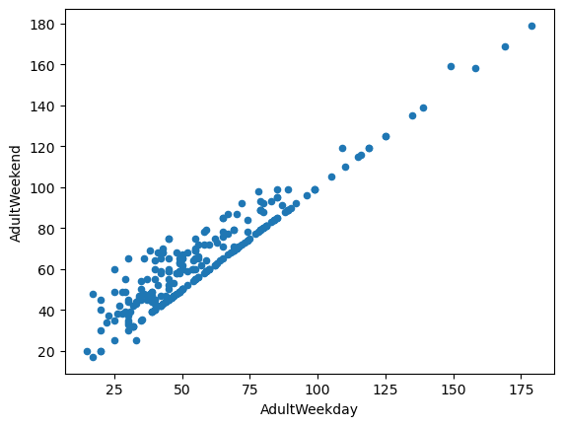

Initial exploratory data analysis began with PCA, which led us to treat the state labels equally. A feature correlation heatmap along with scatter plots against the ticket price showed 'fastQuads', 'vertical_drop', 'total_chairs', 'Runs', and 'Snow Making_ac' as areas of interest.

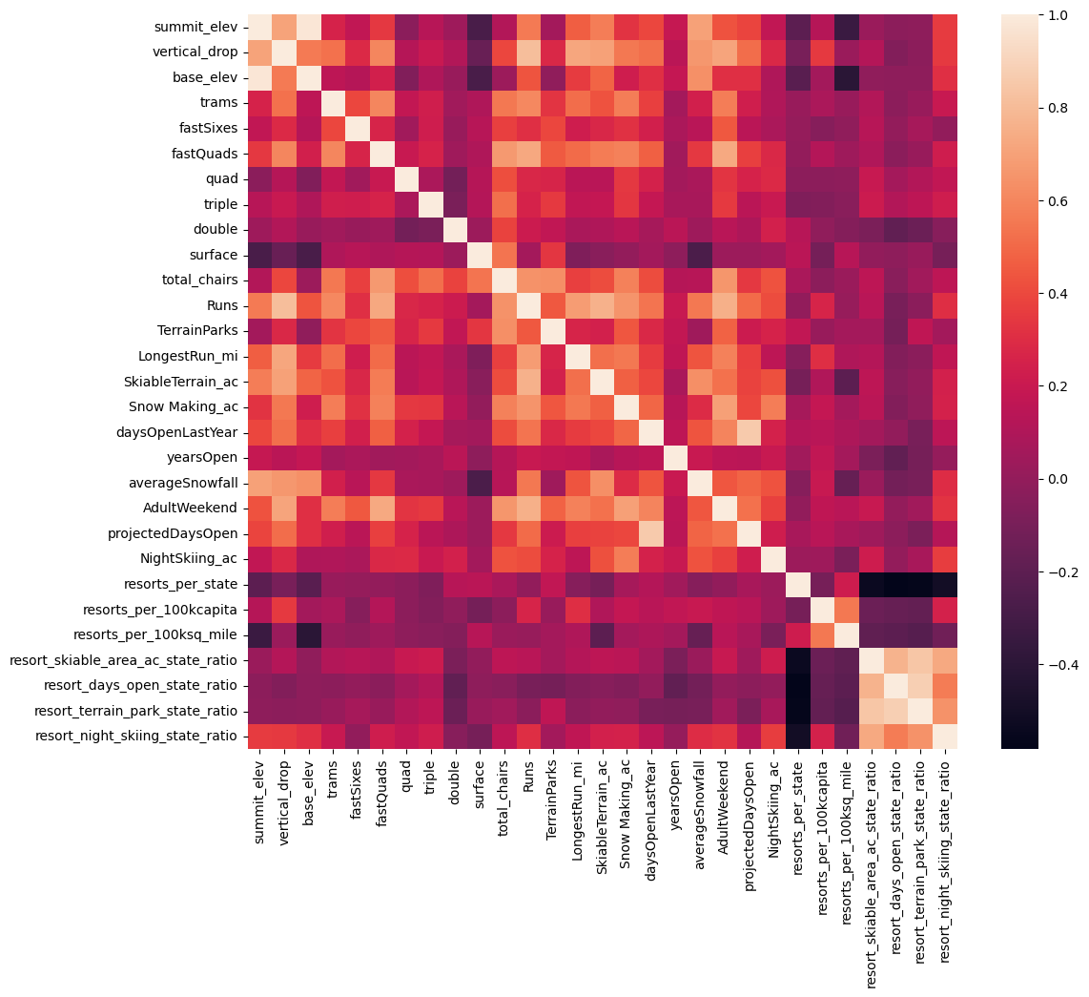

Our baseline idea of performance used Mean Squared Error, which expects that we would be off by $19 based on the average of known values. We built a linear regression pipeline and a grid search cross validation that gave the following top 8 features: 'vertical_drop', 'Snow Making_ac', 'total_chairs', 'fastQuads', 'Runs', 'LongestRun_mi', 'trams', 'SkiableTerrain_ac'. From using 'cross_validate', the random forest model has a lower cross-validation mean absolute error with less variability compared to the linear regression model.

Big Mountain Resort's current ticket price is 81. We must have more data to help us determine whether competitors are overpricing or underpricing and more data on operating costs. Based on the 350,000 expected visitors buying 5 day tickets, the recommended scenario to choose is to increase the vertical drop and add a ski lift as it supports increasing the ticket price. If Big Mountain Resort wants to close runs, the model suggests that closing 3-5 runs have the same plateaued revenue change and that closing 6-8 runs have the same plateaued revenue change.